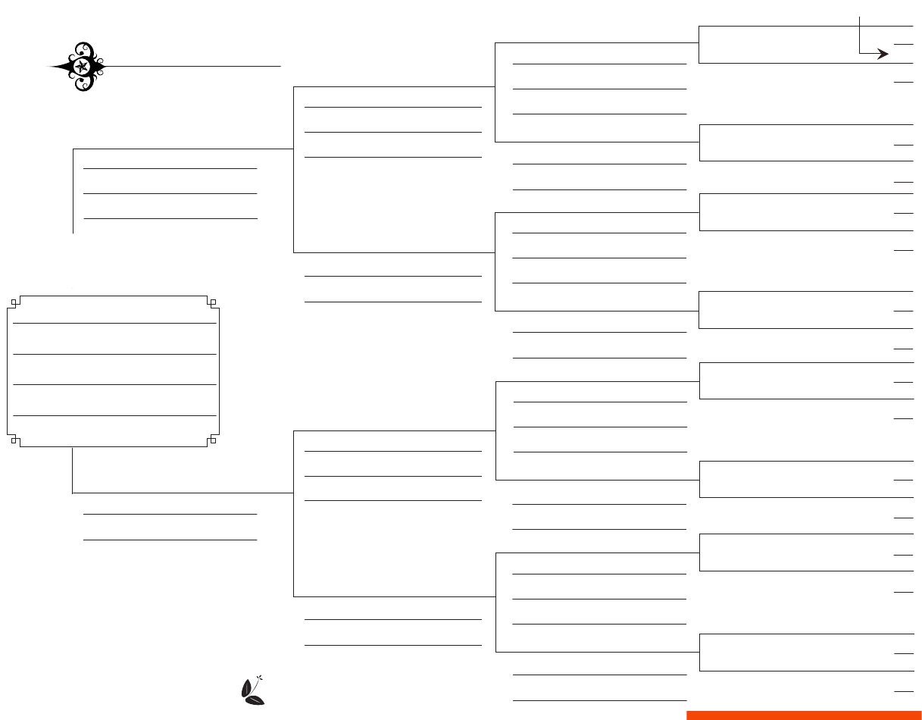
____________________________________________
4
Chart # ____
1 on this chart is = ____ on chart # ____
Birth date and place
16
8
17
Birth date and place
Marriage date and place
View chart # ____
Death date and place
18
19
2
Birth date and place
Marriage date and place
9
Birth date and place
Death date and place
Marriage date and place
10
5
Birth date and place
Death date and place
20
21
Death date and place
Birth date and place
Marriage date and place
1
Death date and place
22
23
Death date and place
Birth date and place
11
Birth date and place
Marriage date and place
12
Death date and place
Death date and place
24
25
Birth date and place
Spouse
6
Birth date and place
Marriage date and place
Death date and place
26
27
3
Birth date and place
Marriage date and place
13
Birth date and place
Death date and place
Death date and place
14
Death date and place
28
29
7
Birth date and place
Birth date and place
Marriage date and place
Death date and place
30
31
Death date and place
15
Birth date and place
logo
Death date and place
Five Generation Family Tree Chart

