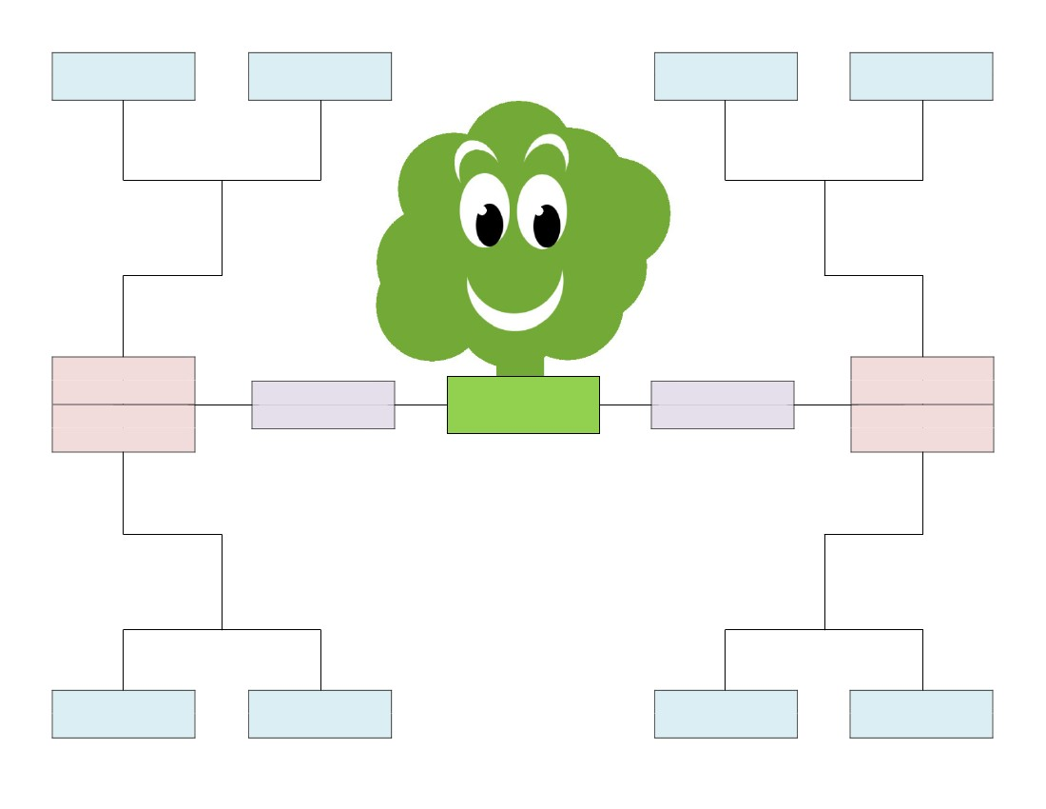
Great-Grandfather:
Great-Grandmother:
Great-Grandfather:
Great-Grandmother:

Grandfather:
Grandfather:
Father:
Grandmother:

Mother:
Grandmother:

My
Family
Tree

Great-Grandfather:
Great-Grandmother:
Great-Grandfather:
Great-Grandmother:

www.FamilyTreeTemplates.net

