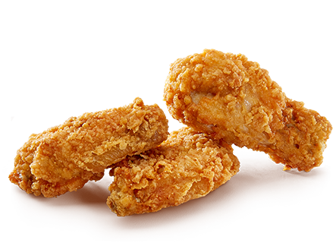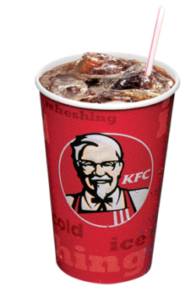

Bucket Sale

15 pieces of chicken

$17

For a limited time only

**Promotion ends 11/23/14**

Delivery charges extra. Premium charges for white meat where available for a limited time only. Delivery charges extra. Premium charges for white meat where available for a limited time only. Delivery charges extra. Premium charges for white meat where available for a limited time only.

Bucket Sale

**Promotion ends 11/23/14**

Delivery charges extra. Premium charges for white meat where available for a limited time only. Delivery charges extra. Premium charges for white meat where available for a limited time only. Delivery charges extra. Premium charges for white meat where available for a limited time only.

15 pieces of chicken

$17

For a limited time only