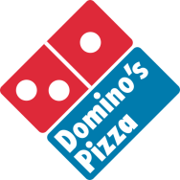

Buy a Large Pizza at Regular Menu Price and Get a Large

1-Topping Free

Delivery charges may apply

Buy a Large Pizza at Regular Menu Price and Get a Large

1-Topping Free

Delivery charges may apply

Buy a Large Pizza at Regular Menu Price and Get a Large

1-Topping Free

Delivery charges may apply

Buy a Large Pizza at Regular Menu Price and Get a Large

1-Topping Free

Delivery charges may apply

Buy a Large Pizza at Regular Menu Price and Get a Large

1-Topping Free

Delivery charges may apply

Buy a Large Pizza at Regular Menu Price and Get a Large

1-Topping Free

Delivery charges may apply

Buy a Large Pizza at Regular Menu Price and Get a Large

1-Topping Free

Delivery charges may apply

Buy a Large Pizza at Regular Menu Price and Get a Large

1-Topping Free

Delivery charges may apply

Buy a Large Pizza at Regular Menu Price and Get a Large

1-Topping Free

Delivery charges may apply